Computer Networks (CS303)

Assignment - 10

**U19CS012**

Problem Statement:

(a) Create Manual to create Network Topology.

(b) Minimum **3 Networks** should be connected to **One Router** and **DHCP Server** should be responsible for assigning IP address to all the systems in topology.

(c) Perform one transmission between two systems belonging to different networks

**Step 1 : LAYOUT**

Create a network shown below using:

1. 1 Router
2. 4 Switches
3. 4 PC’s
4. 4 Laptop’s
5. 1 DHCP Server

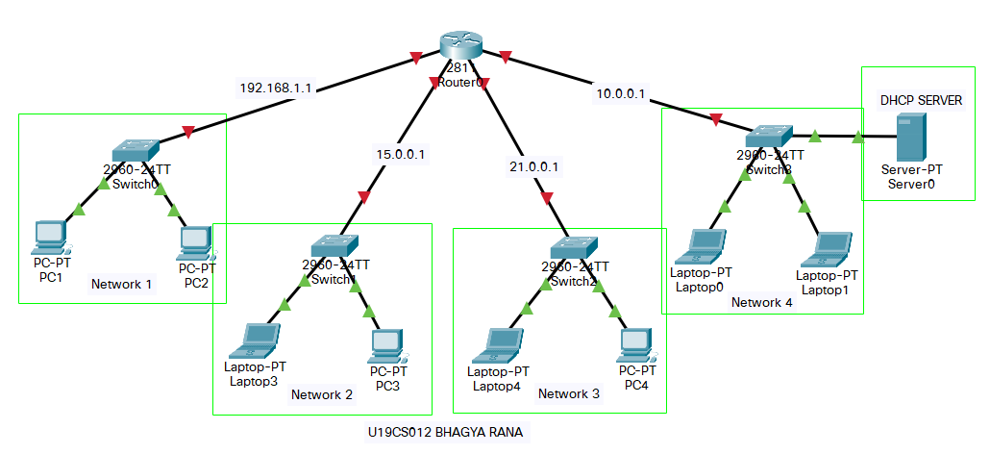

In order to connect more than 2 Networks with Route, We need to Add Modules to it. Here, I am using Router 2811, therefore go to the **Physical Configuration** and add module “**NM-2FE2W**” which enables two more Fast-Ethernet Ports.

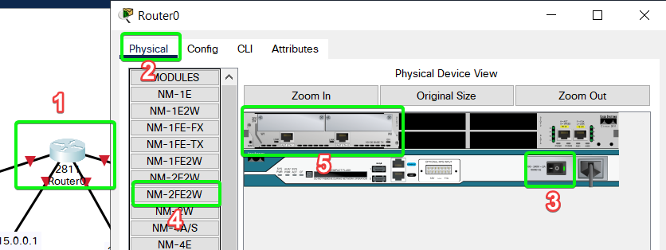

Once this is Complete, you should be able to add 4 different networks to the Router.

**Step 2 : DHCP SERVER CONFIGURATION**

Select the **Server** to open up its **Configuration** terminal and then select **setting** and set it to static with default gateway as “**10.0.0.1**” (the network server is connected to).

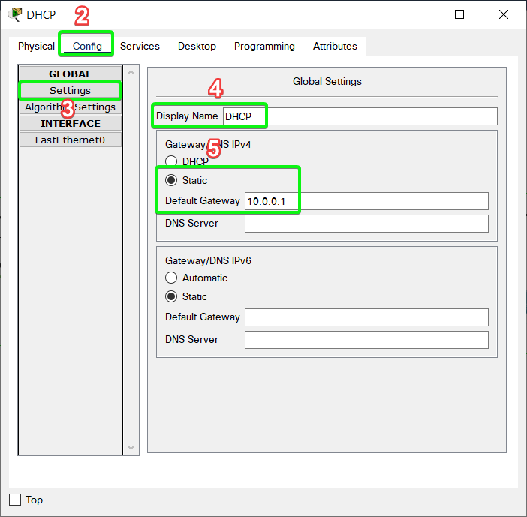

Then Select **FastEthernet0** and set the IPv4 address to **10.0.0.2** with Subnet Mask **255.0.0.0** {automatically appear} which is also in static. Then set the port status to “**ON**”.

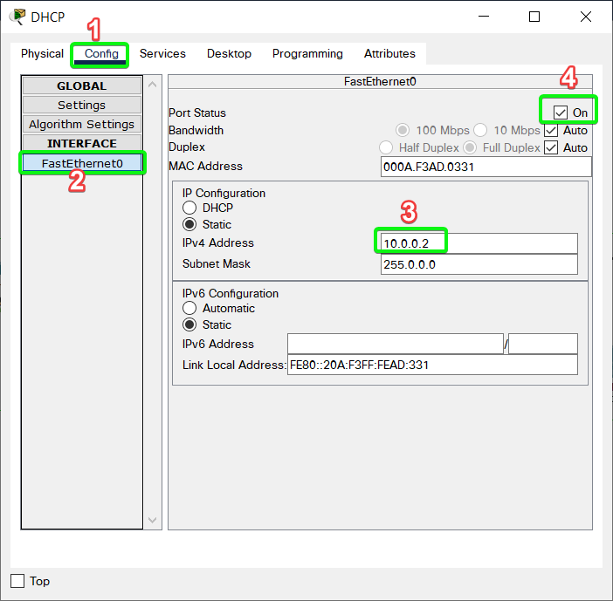

Now select **Services** from top bar and then select **DHCP** and now set the starting IP of each network. Here we would set for 4 networks “**192.168.1.1**”, ”**15.0.0.1**”, ”**21.0.0.1**”, ”**10.0.0.1**”.

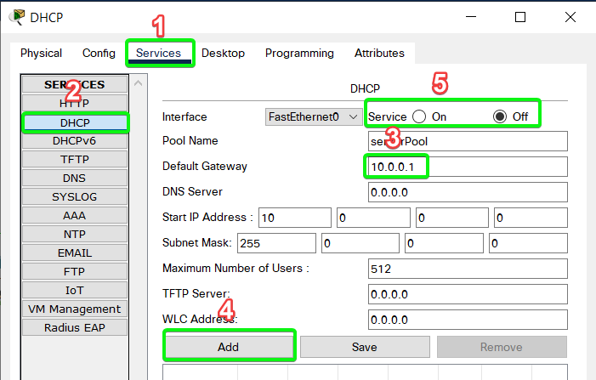

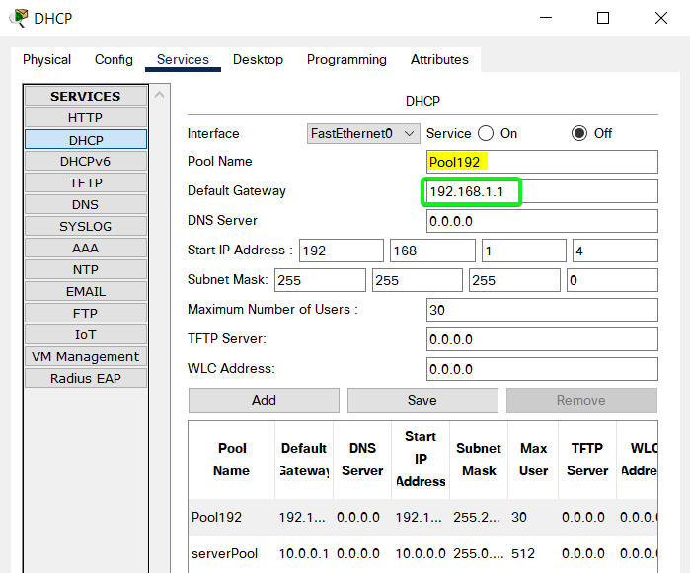

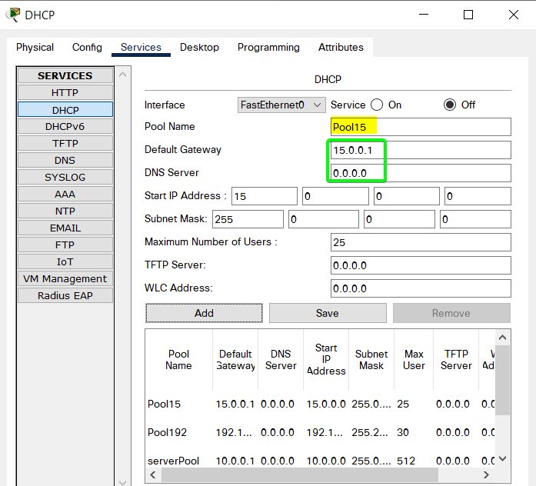

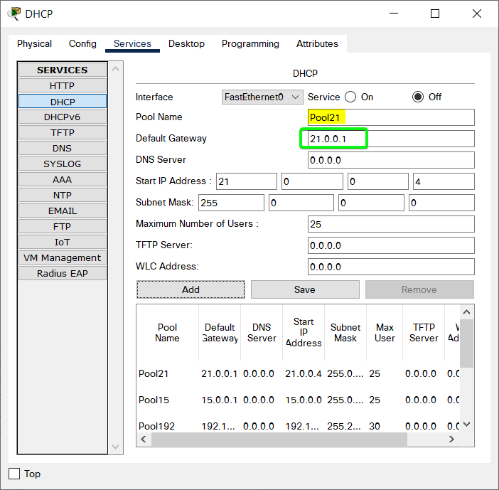

After all the DHCP pools are created, set the service status to “**ON**”

**Step 3 : ROUTER CONFIGURATION**

Now that the server is set, we need to **configure out router** accordingly so first, set the IP’s of each port according to figure in Layout above. Do the same to all ports as shown below.

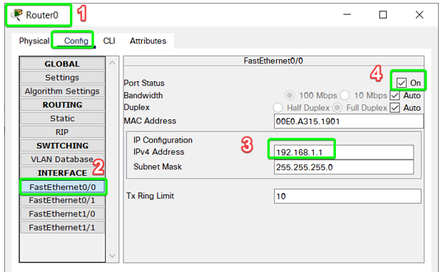

Now, Open CLI and Run the Following Command:

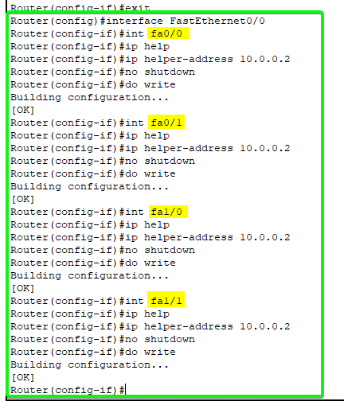

This should make any DHCP IP request from any network to go directly to the server.

**Step 4: END DEVICE CONFIGURATION**

Set the **IP Config** mode from Static to DHCP as shown.

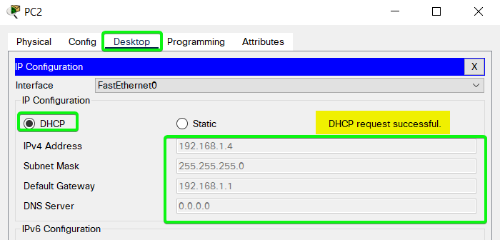

Do Similar Step for All the End Devices {PC’s & Laptop’s}.

After few seconds it should get assigned a unique IP. Do this to all the end devices.

**Step 5: SIMULATION**

From PC1 with IP **192.168.1.5** we would ping Laptop4 with IP **21.0.0.4**.

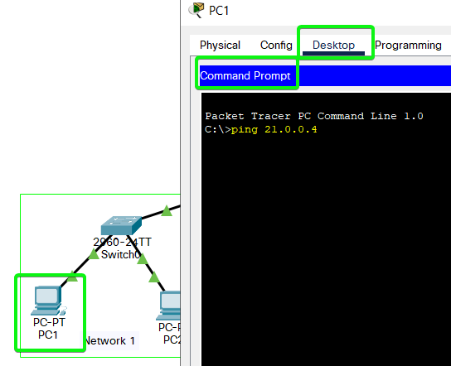

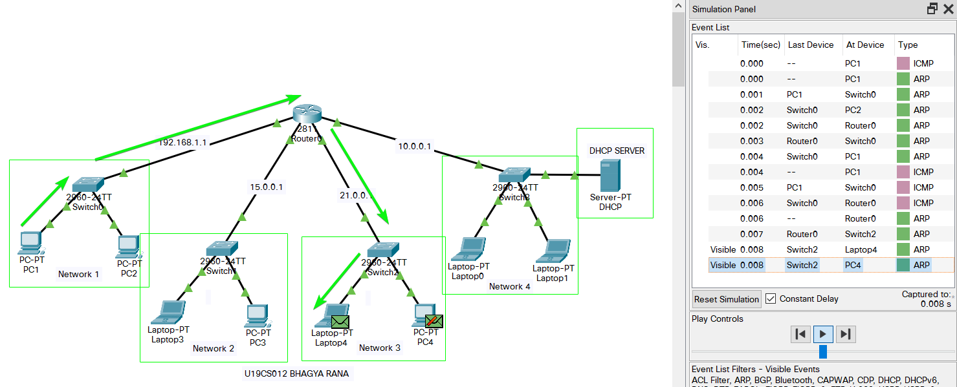

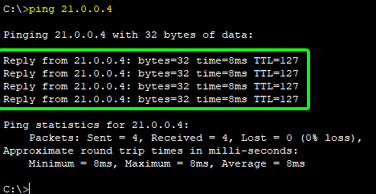

SUBMITTED BY:

**U19CS012**

BHAGYA VINOD RANA